**Project Design Phase-II**

**Technology Stack (Architecture & Stack)**

|  |  |
| --- | --- |
| Date | 03October 2022 |
| Team ID | PNT2022TMID52529 |
| Project Name | Project - Inventory Management System for Retailers |
| Maximum Marks | 4 Marks |

**Technical Architecture:** 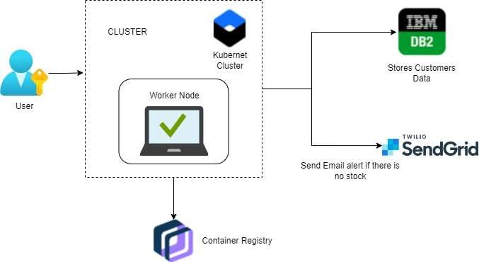

**Table-1 : Components & Technologies:**

|  |  |  |  |
| --- | --- | --- | --- |
| **S.No** | **Component** | **Description** | **Technology** |
|  | User Interface | Through web application, the information processed will be  sent to the user via mail. | HTML, CSS, jQuery, JavaScript, python,  etc. |
|  | Application Logic-1 | User registration through form and confirmation will be  sent to the user via email. | Flask, SendGrid |
|  | Application Logic-2 | Dashboard is used by which the system will  Maintain tracking of sales of product and inventory levels. | Flask |
|  | Application Logic-3 | User will get notified about the stock status. | Flask |
|  | Database | The data can be stored in database and user can retrieve or manipulate the data whenever required. | IBM DB2. |
|  | Cloud Database | Information of the stocks will be stored and hosted  on the cloud. | IBM DB2. |
|  | File Storage | Requirements to store files | IBM Block Storage or Other Storage  Service or Local File system |
|  | External API-1 | SendGrid used in application will send the email alert if there is less number or no stock to the user | SendGrid |
|  | External API-2 | IBM container Registry enables you to store and distribute Docker images in a managed private  registry | IBM container registry |
|  | Machine Learning Model | Purpose of Machine Learning Model | Object Recognition Model, etc. |
|  | Infrastructure (Server / Cloud) | Application Deployment on Local System / Cloud Local Server Configuration:localhost:5001(Flask)  Cloud Server Configuration : Kubernetes | Local, Cloud Foundry, Kubernetes, etc. |

**Table-2: Application Characteristics:**

| **S.No** | **Characteristics** | **Description** | **Technology** |
| --- | --- | --- | --- |
|  | Open-Source Frameworks | SendGrid will send email alert, if there is less number of stock to user, Kubernetes for manipulating Kubernetes API objects, IBM DB2 is used  for storing and retrieving the data efficiently. | Flask, SendGrid, IBMDB2, Kubernetes |
|  | Security Implementations | We use login for the user and the information will  be hashed so that it will be very secure to use. | IBM container registry. |
|  | Scalable Architecture | It is scalable that we are going to use data in kb so that the quite amount of storage is satisfied. | Flask |
|  | Availability | Prediction will be available for every user but only for premium user news, database and price alert will  be alert. | Flask. |
|  | Performance | It will perform fast and secure even at the lower  bandwidth. | Flask, IBM container registry, IBM DB2. |

**References:**

[**https://c4model.com/**](https://c4model.com/)

[**https://developer.ibm.com/patterns/online-order-processing-system-during-pandemic/**](https://developer.ibm.com/patterns/online-order-processing-system-during-pandemic/)

[**https://www.ibm.com/cloud/architecture**](https://www.ibm.com/cloud/architecture)

[**https://aws.amazon.com/architecture**](https://aws.amazon.com/architecture)

[**https://medium.com/the-internal-startup/how-to-draw-useful-technical-architecture-diagrams-2d20c9fda90d**](https://medium.com/the-internal-startup/how-to-draw-useful-technical-architecture-diagrams-2d20c9fda90d)